

Incoming 6th Grade Supply List 2025-2026
Math | ❏ 1 BLUE Quad-Ruled Graphing Composition Notebook (Staples Brand preferred; other brands tend to fall apart)  ❏ 1 BLUE Folder (durable PLASTIC folder ONLY)  ❏ 1 YELLOW Folder (durable PLASTIC folder ONLY)  ❏ 1 box of tissues  ❏ 1 roll of paper towels
ELA | ❏ 1 three-ring binder (1in Size)  ❏ 3 three-ring folders in the binder (durable PLASTIC folders ONLY)  ❏ 1 box of Kleenex  ❏ 1 pack of Post-It Notes  ❏ 1 packet of blue or black ink pens  ❏ 1 roll of paper towels
Social Studies | ❏ 2 ​RED​ Folders ​(durable PLASTIC folders ONLY)  ❏ 1 ​RED​ Composition Notebook  ❏ 1 Box of Pre-sharpened pencils  ❏ 1 Packet of copy paper.  ❏ 1 Tissue box  ❏ 1 Roll of paper towels
Science | ❏ 1 ​GREEN​ composition notebook  ❏ 1 packet of copy paper  ❏ 1 roll of paper towels  ❏ 1 roll of Scotch tape  ❏ 1 bottle of hand soap
Math Exploration | ❏ 1 Black Quad-Ruled Graphing Composition Notebook  ❏ 1 packet of copy paper, 1 box of tissues, OR 1 roll of paper towel [Choose one]
Advisory | 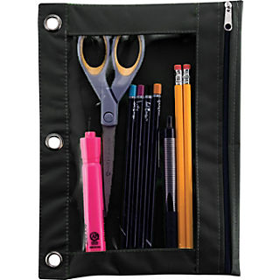  - 1 BLACK folder for family letters, permission slips, PA notices, etc.  The following supplies should be stored in the student’s pencil case:  - 1 Pencil Case (large fabric case with a zippered pocket on the side to store the calculator is suggested)  - 1 Pencil Sharpener  - 1 Eraser  - 4 different color highlighters  - Personal Supply of Pencils  - 1 Pair of Headphones/Earbuds  - 1 Pack of Expo Markers  - 1 set of colored pencils
Elective Classes | ❏ Please bring TWO of the following:  white copy paper, paper towel roll, or tissues**  **Please bring items to Ms. Schorr (Rm 115) or Ms. Li (Rm 423), and they will share with the elective teachers.

